**ASE – Lab #9**

**Home Page**

Started with the Tutorial 9 code. Rewrote the index.pug file to include the login form that included a button that would go to the /login route. The index.js file is how the program gets started and uses the index.pug to format the page. The /login route reads in the data from the form and writes it to the cookie before sending the user to the /cookiedata route.

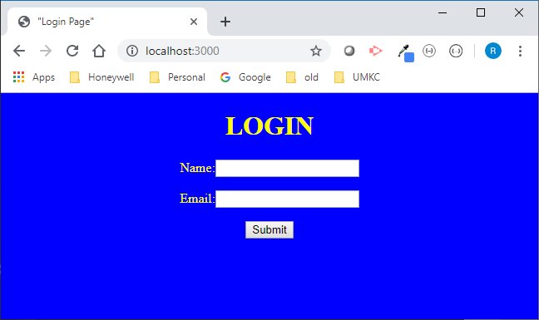

**Cookiedata route/page**

The cookiedata route is displayed with the /login route with the form data passed as parameters. It displays the cookie data and provides a form with a single button to allow the user to return to the home page.

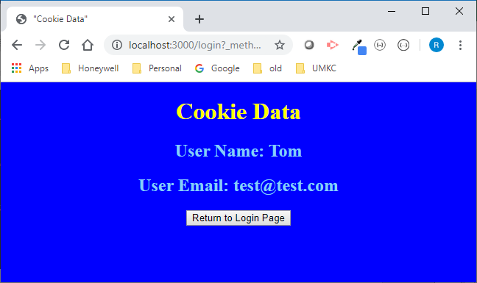

As can be seen on the Chrome Development tools/Inspection page, you can see that the cookie was set to agree with the display.

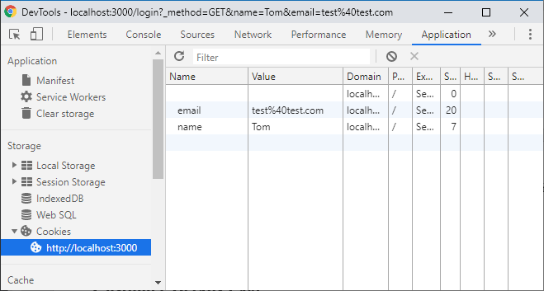

**Contribution**

**Lab ID: 3_2**

Dukkipati Sri Sai Nithin Chowdary (Class Id 05)

* Design and debugging the application.

Rod Skoglund (Class Id 23)

* Coding and documentation.